Live Q&A 6 Transcript

Preliminaries
There are quite a lot of videos this week. However, the total viewing time isn’t actually much longer than previous weeks – it’s just shorter videos.
Just so you can plan ahead, next week assignment 2 will start.
Several people are involved in the marking for coursework. The official policy is that the marks will be returned after 4 weeks.

Itempool Quiz

Which one is right?
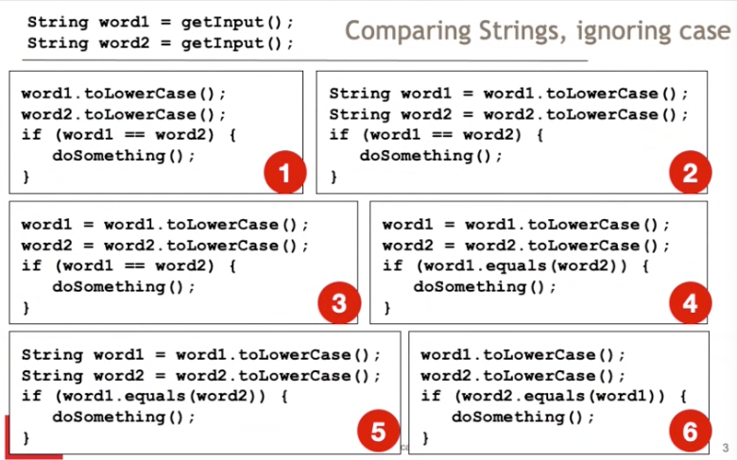

It’s 4.
It’s not 6 because strings are immutable. As a result, .toLowerCase() is giving a result and not returning it to a variable.
It’s not 5 because when declaring a variable, it will refer to that variable for .toLowerCase().

Pollev questions

What sort of material will the second assignment cover?
The material will cover stuff from next week. It will be a lot more elaborate, larger and a lot more scope to add your own ideas.

Will we learn front-end web development in any other modules?
Yes, but not in this modules.

If I is allowed for loops, does it mean we can use j and k as well if we have nested loops?
Yes, this is common practice. However, if you have nested loops, it is better to make a method for a nested loop. This is to do with a concept called cohesion.

Will we have a lot of material to cover while we are doing the coursework?
You do the coursework in addition to doing the study material. However, it will be directly related to the assignment.

Difference between += and =+?
In the first case, it is used as an increment. In the second case, it takes the + as a sign value.

When will we learn about main classes and using normal ides?
We will talk about main classes next week. Normal IDEs are for next term.

Can you explain the difference between ++i and i++?
i++ – A value is read, and the value is incremented.
++i – The increment happens before the assignment.
In modern code, it is easier to just use two lines of code in order to prevent misinterpretation. You’re making the execution order much clearer. These optimisations are an artefact from programming in the 1960s where it is important to optimise to the variable level. However, there are optimisations under the hood far better than your attempts to optimise.

Will the exam be taken online?
Every exam will be taken online, yes.

Can we use += with other operations, like -= or *=?
Yes, if you have the operations defined.

Why can’t we use a for loop instead of the while loop. Isn’t it so much easier with less lines of code inside of the loop?
You could, but the complexity is about the same. I just wanted you to demonstrate that you could use while loops.

I’ve just learnt str.charat(i) by googling it, should we google things to program more than watching only lecture videos?
Yes and yes.
